SUPPLEMENTARY MATERIAL

Chemo-Enzymatic Synthesis of Conformationally Constrained Oligosaccharides
M. Carmen Galan, ª Andre P. Venot, ª John Glushka, ª Anne Imberty, ^{b} and Geert-Jan Boons*ª

NMR experiments
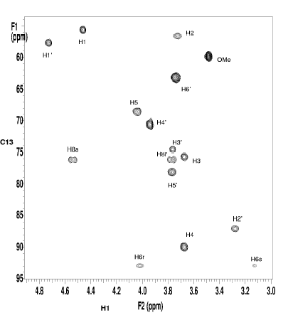
Figure 1. Region of 500 MHz H1{C13}-HSQC spectrum of compound 4 in D₂O at 25ºC. The anomeric signals, H1 and H1', and the H6 signals are folded in the carbon dimension; correct chemical shift values are found in Table 2 (main text).

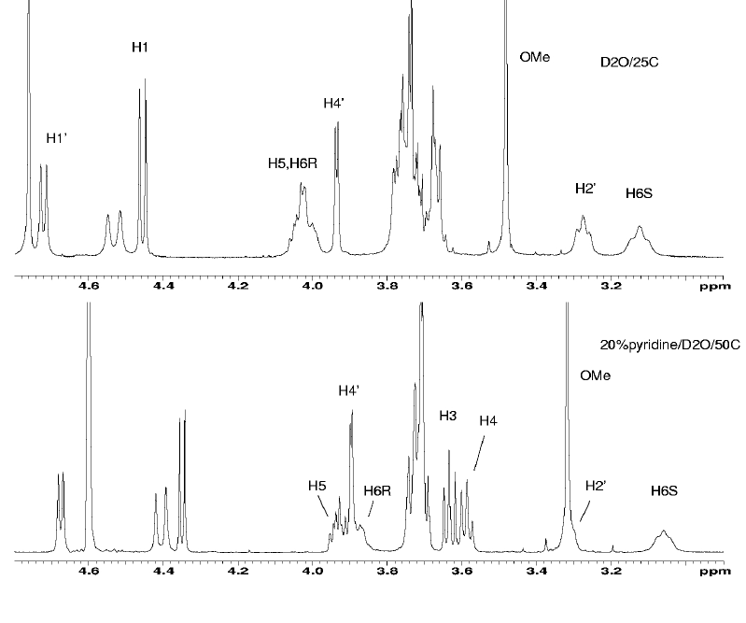

Figure 2. 600 MHz proton spectra of compound 4. Top trace is D₂O at 25ºC; Bottom trace after adding 20% pyridine at 50ºC. The chemical shift scale of the bottom trace is approximate.

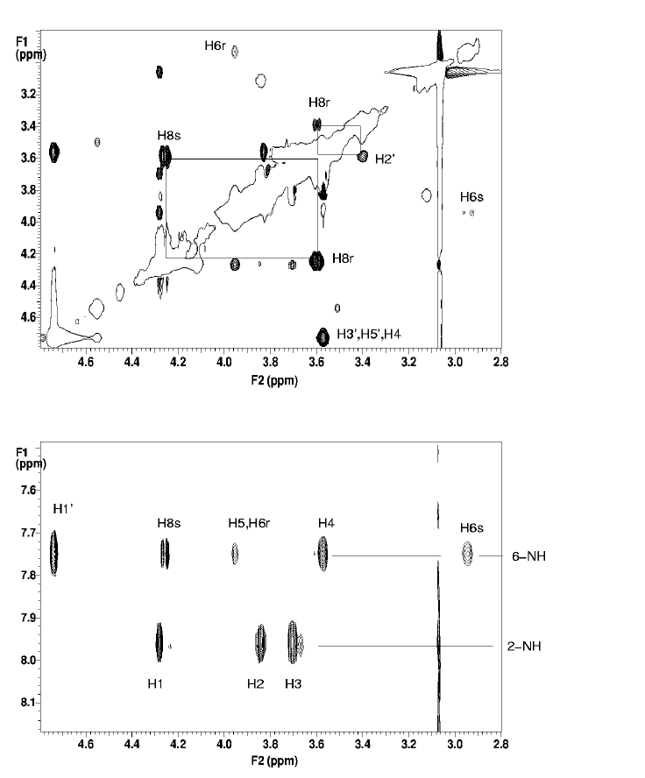

Figure 3. Regions of 800 MHz ROESY spectrum of compound 4 in 10% DMSO/pyridine, showing some observed NOEs. The lower panel shows crosspeaks between the 6-amide proton and other resonances. See text for discussion.

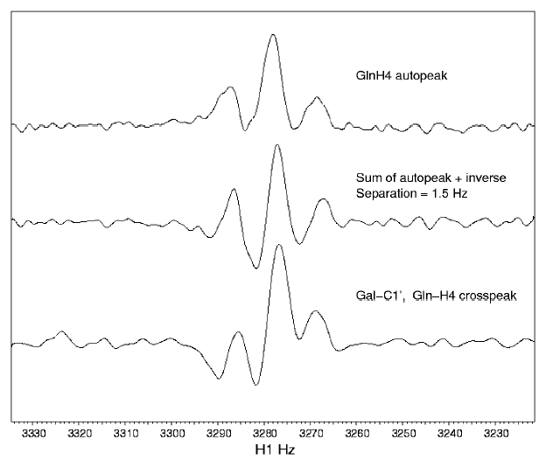

Figure 4. Determination of ³J_{C1'-H4} for compound 4. Top: a trace through the C4-H4 autopeak in the 2D HSQMBC spectrum; Middle: sum of the above trace with its inverse, shifted by ~1.5 Hz; Bottom: trace through the C1'-H4 crosspeak in the 2D HSQMBC spectrum.

Molecular Mechanics Calculations

Figure 5. Nomenclature: Torsion angles at the glycosidic linkage have been defined with reference to the hydrogen atom: Φ_{Η}= H₁'-C₁'-O₁'-C₄, Ψ_{Η} = C₁'-O₁'-C₄-H₄. All other torsion angles are defined as indicated as follow. Galactoside atoms are primed and N, C_{7’} and C_{8’} belong to the linker.

Table 1. Characteristics of the conformational families that can be adopted by compound 4. Only average values of torsion angles (°) are given for each family. Possible ranges for Φ_{Η} and Ψ_{Η} are given in Figure 2 (main text). For the other torsion, variations in each families are less than +/- 20° around the average value.

 | Nb^{[a]} | Φ_{Η} | Ψ_{Η} | ω2 | μ2 | ν2 | ν6 | μ6 | ω6 | Erel^{[b]}
Trans_ap | 28 | 40 | -30 | -50 | 65 | 45 | -170 | 95 | 170 | 0.0
Trans_p | 38 | 23 | -45 | 93 | -65 | -37 | 174 | -75 | -155 | 0.3
Trans_p_2 | 17 | 60 | -20 | -30 | 70 | -115 | 171 | -65 | -165 | 3.3
Cis_p | 2 | 30 | -5 | -75 | 60 | 60 | -5 | -130 | -75 | 3.6
Cis_ap | 7 | 0 | -30 | 120 | -55 | -70 | 0 | 120 | 165 | 3.7
^{[a]} Number of conformations obtained by clustering methods
^{[b]} Relative energy (Kcal/mol) calculated after complete optimization of the lowest energy conformation of the family.

Table 2. Experimental and theoretical NMR data of the optimised 4.

 | NMR  pyridine/ D20 | NMR pyridine/DMSO | Theoretical value
Coupling constants (Hz)
JH1'-C4 | 4.4 | Not measured | 4.5
JC1'-H4 | 1.5 | Not measured | 1.4
JH5'-H6 _{proR} | 5 | Not measured
JH5'-H6 _{proS} | 10 | Not measured
Proton distances (Å)
H1'-H4 | 2.3 | Not measured | 2.4
H1'-H3 | 3.0 | Not measured | 3.1
H2' – H8_{proR}' | N.O.ª | Observed | 2.4
NH – H4 | N.O.^{b} | Observed | 2.4
NH – H6_{proR} | N.O.^{b} | Observed | 2.9
NH – H6 _{proS} | N.O.^{b} | Observed | 2.4
NH – H1' | N.O.^{b} | Observed | 3.6
NH – H8_{proS}' | N.O.^{b} | Observed | 2.6
N.O.ª not observed due to signal overlap
N.O.^{b} not observed due to NH proton exchange with D₂O

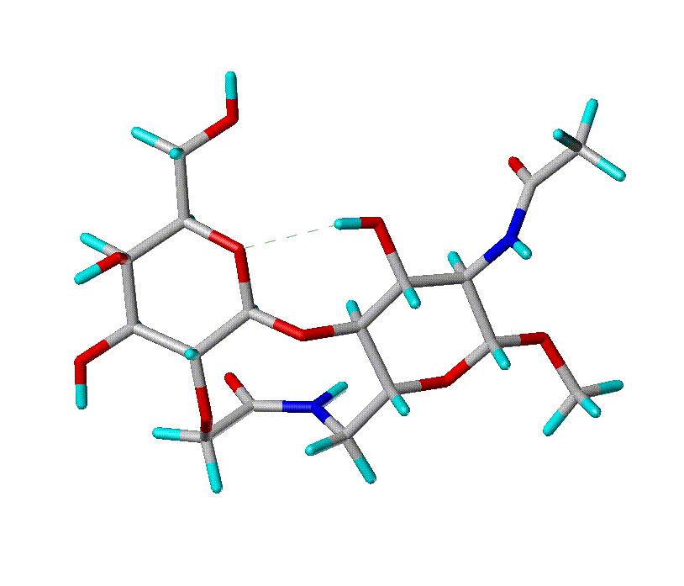
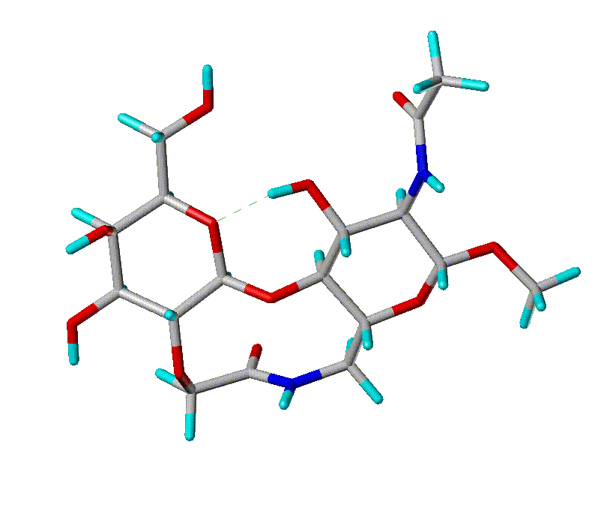
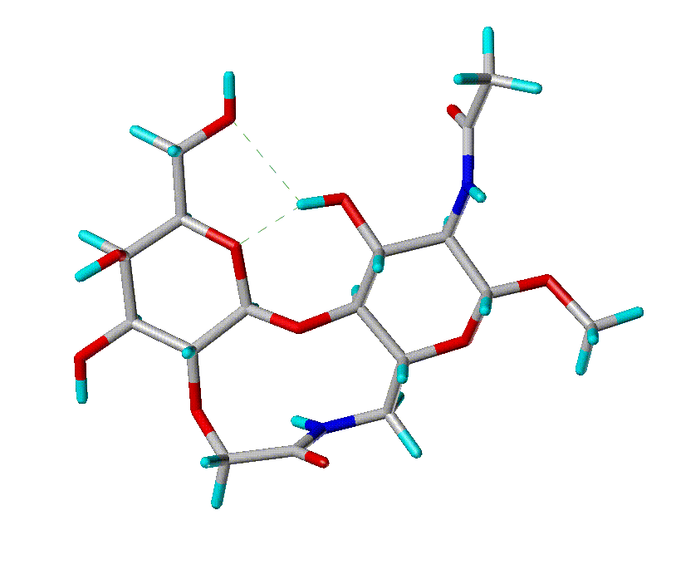
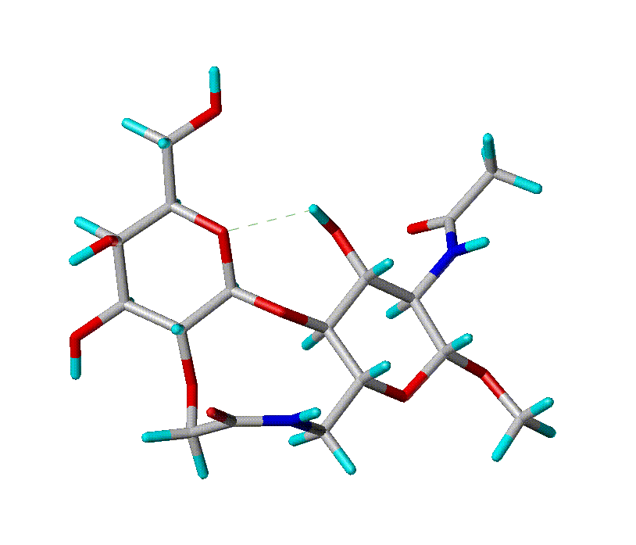
Trans_p
Trans_ap
Cis_p
Cis_ap

Figure 6: Low energy conformation of compound 4.

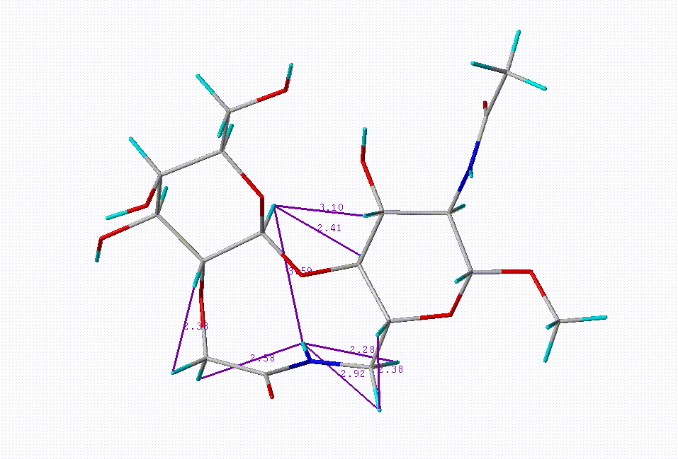

Figure 7: Low energy conformation of compound 4 together with proton distances of interest.

Procedures for Enzyme Kinetics

Sialyltransferase Assays
Reported methods^{[1-4]} were employed for assaying sialyltransferase activity. For studies of the relative rates, incubation mixtures contained CMP[¹⁴C]Neu5Ac (9 nmol, 6180 cpm/nmol) and substrate (120 nmol), bovine serum albumin (1mg/ml), 57 μU of α-2,6-Sialyltransferase in sodium cacodylate (50 mM, pH 6.5) containing 0.1% Triton X100 in a total volume of 60 μL were incubated at 37 ºC for a period of 30 min. The radiolabeled product was isolated using a procedure modified by Horenstein et al.^{[4]} based on Paulson’s ion-exchange chromatography on a Dowex 1X8-200 (PO₄²⁻, 100-200 mesh) Pasteur pipette column.^{[1]} Columns (5 cm high) were eluted twice with 1 mM PO₄²⁻ (4 mL) buffer to ensure that no radiolabeled product was left on the column.
Kinetic studies. Apparent kinetic parameters of the α-2,6-ST for synthetic acceptor 4 was determined under the above standard conditions using a saturating concentration of CMP-[¹⁴C]Neu5Ac.^{[2]} Assays were performed in duplicate using the appropriate amount of each of enzyme. The concentration of oligosaccharide acceptor was varied around the K_{m} value (see supplementary material), whereas the concentration of CMP-[¹⁴C]Neu5Ac was kept constant at 200 μM (1655 cpm/nmol). The time of incubation at 37ºC was limited to 15 min. to limit the CMP-[¹⁴C]Neu5Ac consumption to 10–15 % to ensure initial rate conditions. The kinetic parameters V_{max} and K_{m} were determined using the GraphPad computer program obtained from Prism.

Fucosyltransferase Assays
Reported methods^{[2, 5]} were employed for assaying fucosyltransferase activity. For studies of the relative rates, incubation mixtures contained GDP[¹⁴C]Fucose (2.3 nmol, 6532 cpm/nmol), substrate (150 nmol) and 50 μU of FucT V assayed in sodium cacodylate (25 mM, pH 6.5) containing MnCl₂ (8 mM), ATP (1.6 mM) and NaN₃ (1.6 mM) in a total volume of 50 μL were incubated at 37 ºC for a period of 60 min. The radiolabeled product was isolated using ion-exchange chromatography on a Dowex 1X8-200 (Cl⁻, 100-200 mesh) Pasteur pipette column.^{[5]} Columns (2.5 cm high) were eluted twice with ice-cold water (1.5 mL) to ensure that no radiolabeled product was left on the column.

References:

[1]. Paulson, J. C., Rearick, J.I. and Hill, R.L. (1977) J. Biol. Chem. 252, 2363-2371.
[2]. Palcic, M.M.; Venot, A.P.; Ratcliffe, R.M. and Hindsgaul, O. (1989) Carboh. Res. 190, 1-11.
[3]. Wlasichuk, K. B., Kashem, M.; Nikrad, P.V.; Bird, P.; Jiang, C. and Venot, A.P. (1993) J. Biol. Chem. 268, 13971-13977.
[4]. Horenstein, B. A., and Bruner, M. (1998) J. Am. Chem. Soc. 120, 1357-1362.
[5]. de Vries, T., Srnka, C.A., Palcic, M.M., Sweidler, S.J., van den Eijnden, D.H. and Macher, B.A. (1995) J. Biol. Chem. 270, 8712.

